How to read the new weekly occupancy report

Background and Context
The Weekly Occupancy report has been around in one form or another for many years. It began as a way to see the system use of Transitional Housing programs and has over time grown to encompass more and more programs and program types. It is meant to be used as a tool to see a snapshot of our system’s occupancy and vacancy rates and to facilitate the coordinated entry process of matching clients to open beds in programs.

Limitations of this report
This report does have some limitations that should be noted before making decisions or publicizing anything in this report. This list may not be comprehensive.
- This report does not include all programs in DC’s CoC and cannot be used to discuss the COMPLETE system of DC’s CoC.
  - This report only includes programs that participate in HMIS. This means there are NO DV programs included in this report, nor are privately funded programs required to be in this report.
  - This report does not currently include most Low Barrier Shelters.
  - This report does not currently include Hypothermia Shelters
  - This report does not include Family Shelter Overflow Hotels/Motels.
- Some Agencies do not submit their held and offline units, so we cannot guarantee the numbers are 100% accurate.
- This is information that is true as of each Thursday. The further from Thursday, the less likely this information is still true.

The Updated Weekly Occupancy Report
This report merges the old report’s 3 tabs into a single, collapsible sheet of information. You can view all details or only the pieces that interest you. This will go over the various ways to look at the report and what each column is and how it is calculated if applicable.

Fully Condensed
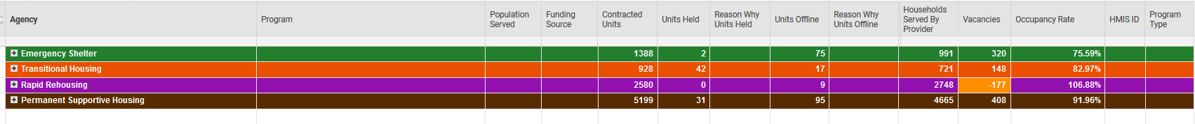
This way of looking at the report gives the top line numbers of our system use only.
Green = Emergency Shelter
Orange = Transitional Housing
Purple = Rapid Rehousing
Brown = Permanent Supportive Housing
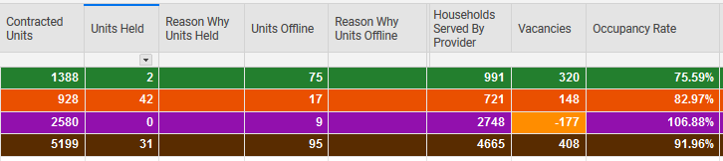

Contracted Units
This the total number of units we have contracted for that program type. It is the sum of the contracted units amounts from each program in the category. This number can change as programs close and open or if they have changes in funding that increase or decrease their contracted units.
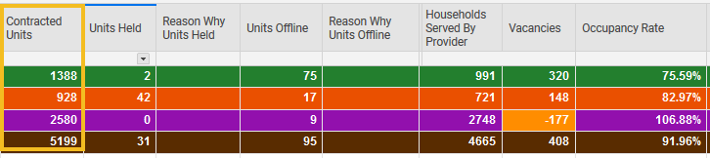

Units Held
This is the total number of units in the program type that are being held. Reasons for a unit being held include a client or household being matched to the program via CAHP. The specifics of why units are held are located at the program level of this report.
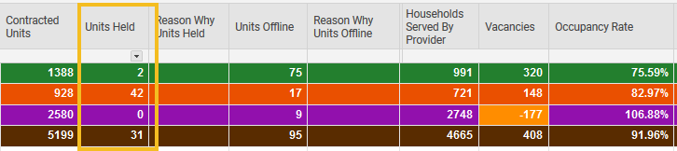

Units Offline
This is the total number of units in the program type that are offline. Reasons for a unit being offline vary from short-term maintenance, long term building improvements, or even if there is an extra-large family in the program that must use multiple units. The specifics of why units are offline are located at the program level of this report.
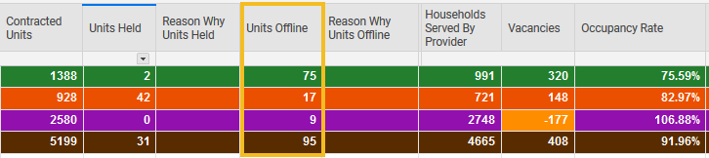

Households served by Provider
This is the total number of households served in the program type. This information is based off programs’ self-report unless they do not supply that information to us, in which case we pull the information out of HMIS. As HMIS data quality improves, we may move to only pulling out of HMIS this specific number.
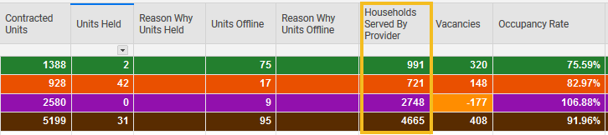

Vacancies
Vacancies is a calculated field. It takes the contracted units and removes the units held, the units offline, and the households served by the provider. This gives the number of units that are available for placements as they are vacant.
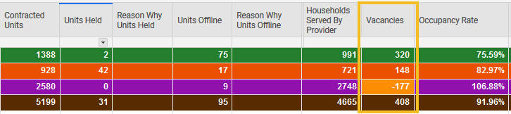

Occupancy Rate
Occupancy Rate is a calculated field. It takes the number of households served and divides that by contracted units minus units held and minus units offline. The higher the percentage, the more occupied the program type beds are.
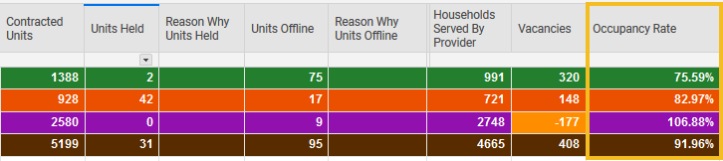

Sub-categories
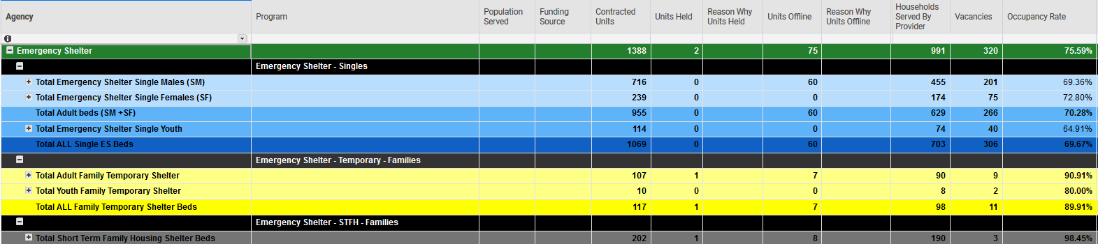
If you click the plus sign on any of the program type lines, it will open the program type to show sub-categories of the program type. These sub categories all add up into the main program type. The sub-categories are color coded with lighter hues get added together to create the darker hues, and then the darker hues of each color are added together to create the color of the main program type line.
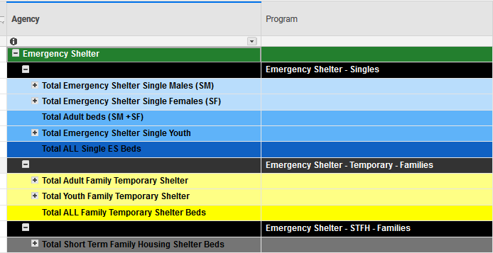
In this case, the light blue adds together to create the medium blue for Adult beds. The two medium blue lines get added together to create the dark blue line. This gets added to the dark yellow and the grey lines to create the green line that is all Emergency Shelters.
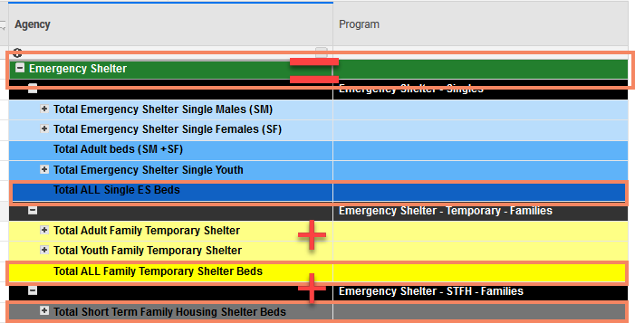
This level of the report gives you all the information previously found on the first tab of the old version of the report.

Provider/Program Detail information
Opening the report further will show information previously found on the two detail tabs. This includes a line for each program/HMIS provider participating in this report. At this level information about why units are held or offline appears. HMIS IDs and funding sources also appear.

Singles
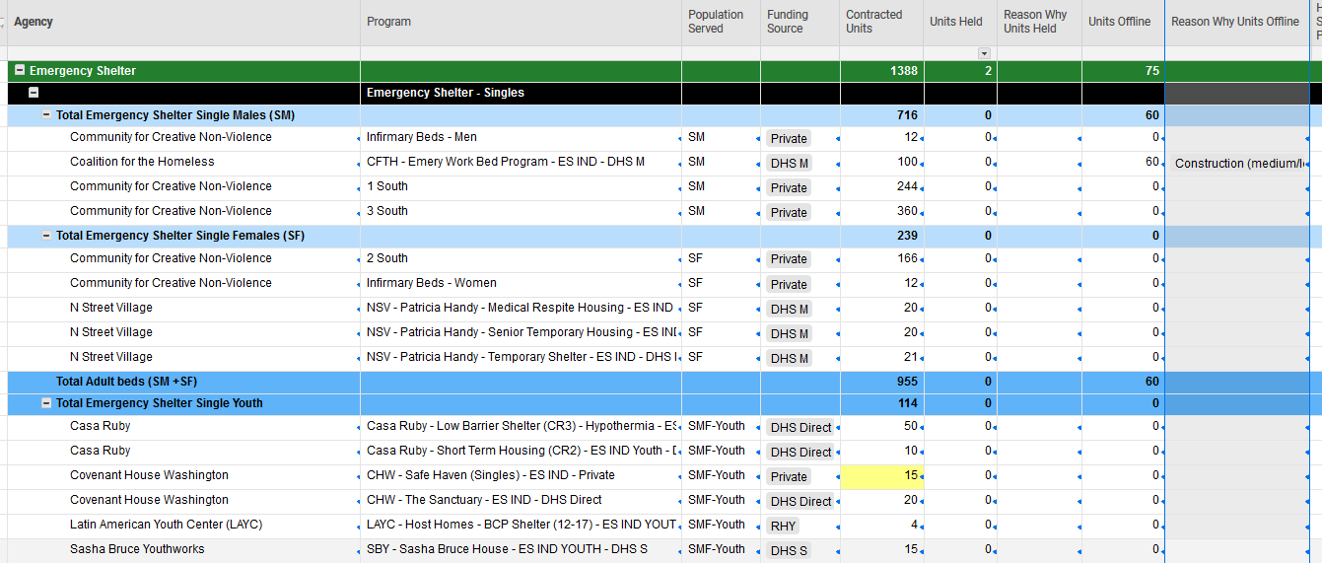

Families
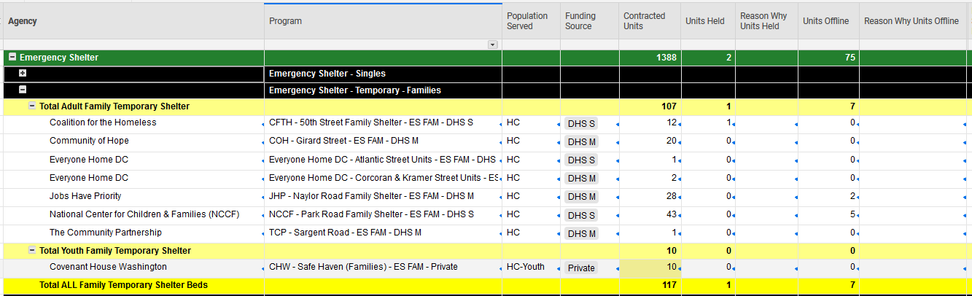

Short Term Family Housing
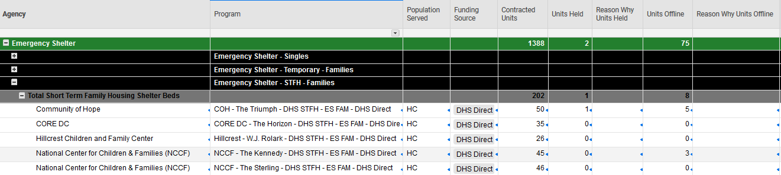

This pattern of singles and families is repeated in each program type (Emergency Shelter, Transitional Housing, Rapid Re-housing, Permanent Supportive Housing).

