Weekly Occupancy Report User Guide

Completing the form on Thursday
You will receive an automated email every Thursday asking you to update your responses. It will show you what is currently in the report and a button to open the update form.
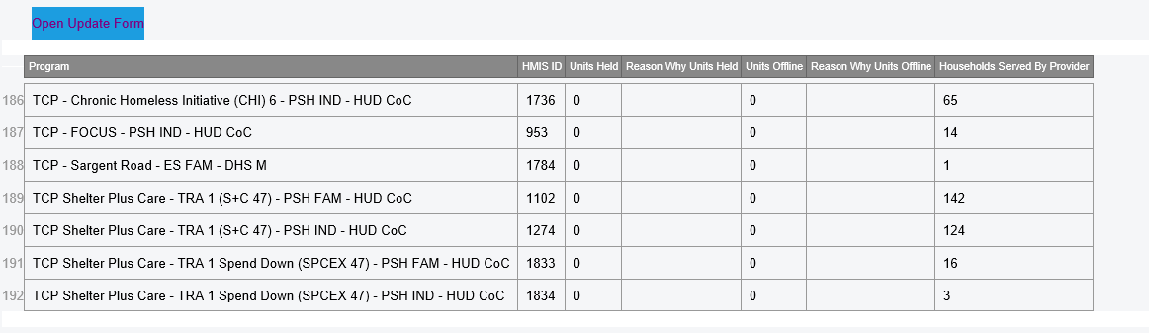

The Form
Each provider/program is its own form. If you have multiple programs, you will see a next button.
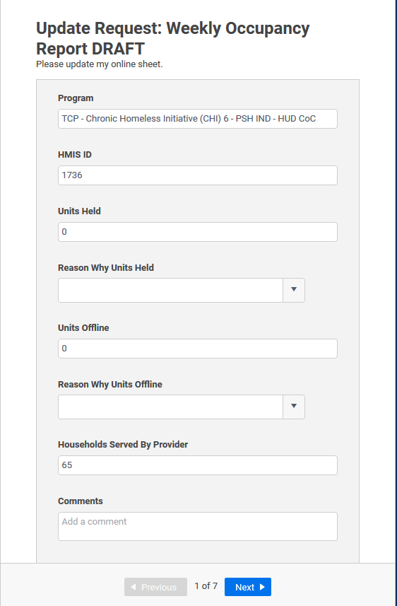

Program and HMIS ID
These are not to be changed. They are there for you to be able to know which program we are talking about.
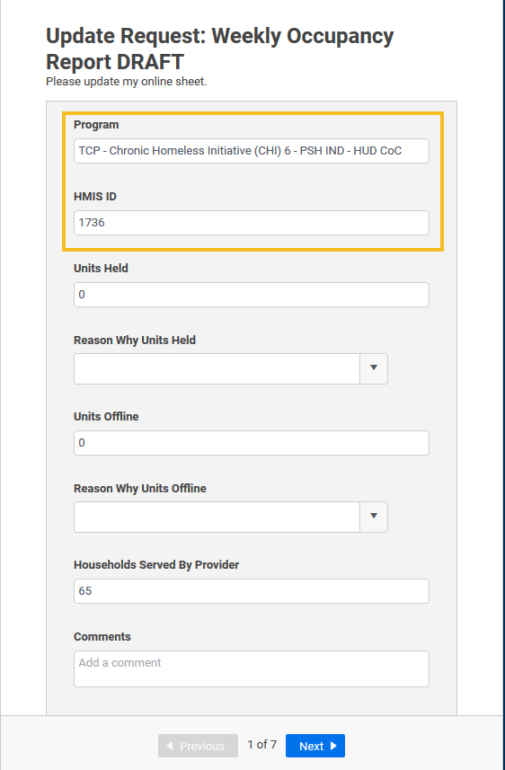

Units Held
These are the number of units/slots held for clients/households that are about to move into, but have not yet, a shelter or transitional housing program, as well as CAHP Matches. If there are no units held, please type 0.
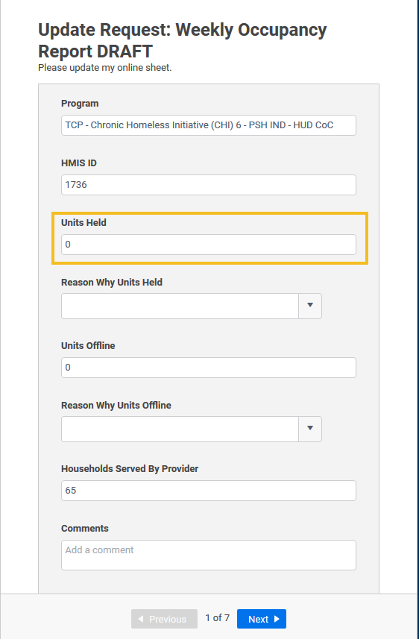

~NEW~ Reason why Units held
In order to bring more transparency and clarity to why units are being held, we have added this question. It is currently sparsely populated, so if the answer is other, use the comments section to better describe the reason. As we find consistent reasons for units being held beyond CAHP matches we will add them to the drop-down menu.
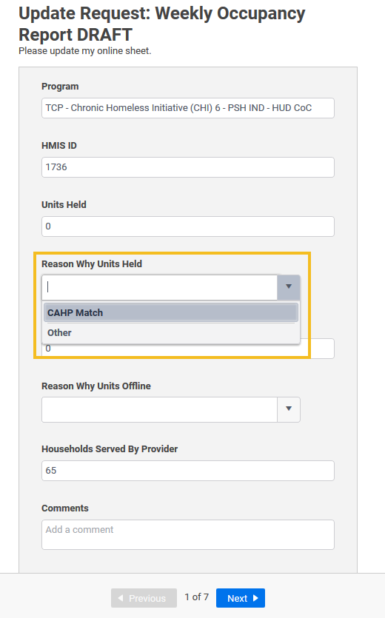

Units Offline
These are the units that are unavailable for placement due to various reasons. A list of potential reasons is available in the next section.
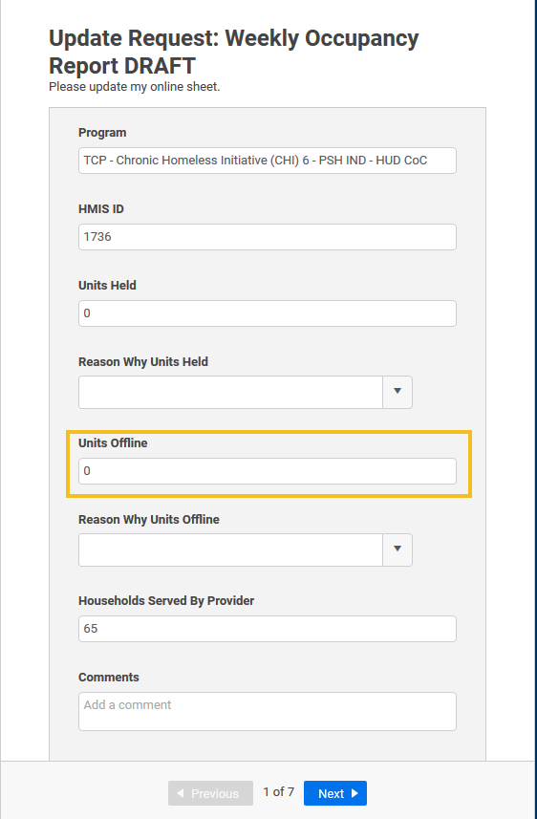

~NEW~ Reason why Units Offline
In order to bring more transparency and clarity to why units are offline, we have added this question. It is currently sparsely populated, so if the answer is other, use the comments section to better describe the reason. As we find consistent reasons for units being offline beyond those options already available we will add them to the drop-down menu.
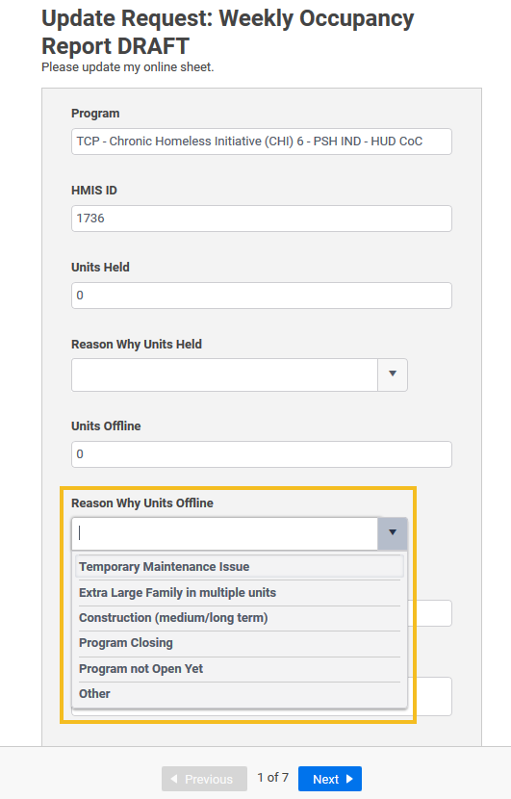

Households Served by Provider
This is the number of households in your program on Thursday. This should only be those actually in your program, not including those waiting to come into your program or those who have exited and are waiting for an appeal process.
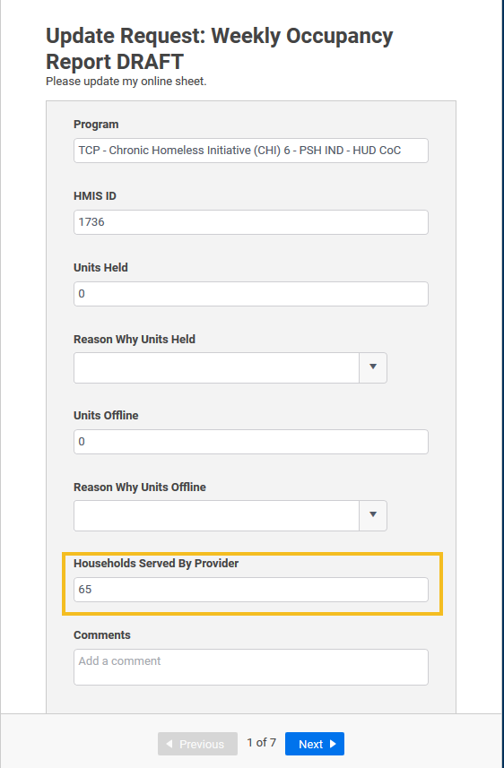

~NEW~ Comments
If you have additional information you would like us to know, or if you chose “Other” for either of the “Reason…” categories, please use the Comments section to describe.
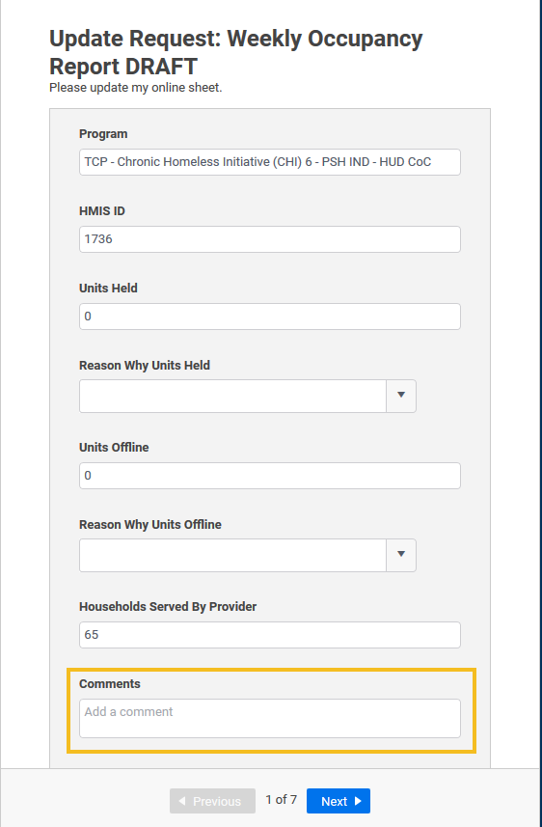

Next Program or Done
Once you have answered all the questions, you will either select “Next” to go to your next program, or you will select “Done” to submit your answers for the week. Once you have completed all your programs, you will see the “Done” option.
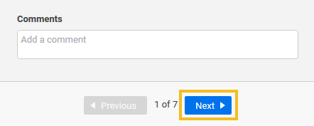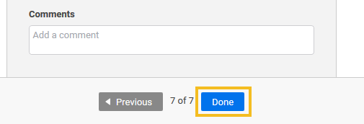

Monday incongruency Emails
On Monday, you will receive emails about your programs letting you know if there are any differences between the numbers you reported on Thursday and then number of clients served in HMIS. If there are differences in the numbers, make sure your data entry is up to date and correct. If there are no differences, all is well and no additional action is needed.

What the report pulls (and doesn’t pull)
We use an ART Report that shows us the number of households in a program on a given date. The number of households is calculated by the number of entry/exit group ids there are associated with the program.
- What does Entry/Exit Group Id mean?
  - This is the id that lumps households together in Entry/Exit. Each time an entry/exit is created (whether for a single individual or a household) a new Entry/Exit group id is created specific to that Entry/Exit.
  - If you add additional household members to an existing entry/exit, they will be included in the existing entry/exit group id.
  - If you add multiple entry/exits for the same household, multiple entry/exit group ids will be created.
    - This is also true if you create an entry/exit for a household member separate from the household entry/exit.
- This report pulls all active Entry/Exits for the provider. It does not currently differentiate between those with only Entries and those with Entries AND Housing Move in Dates.

Common Data Entry Errors
Given this information about how the report defines household numbers, there are a number of common ways that data entry can cause errors in the report.

Entries under the Agency Provider
If you are seeing that your HMIS count numbers are lower than your reported numbers, check to make sure that there are not any entries created at the Agency Provider instead of the program provider.
- Go to the CoC APR Report in HMIS
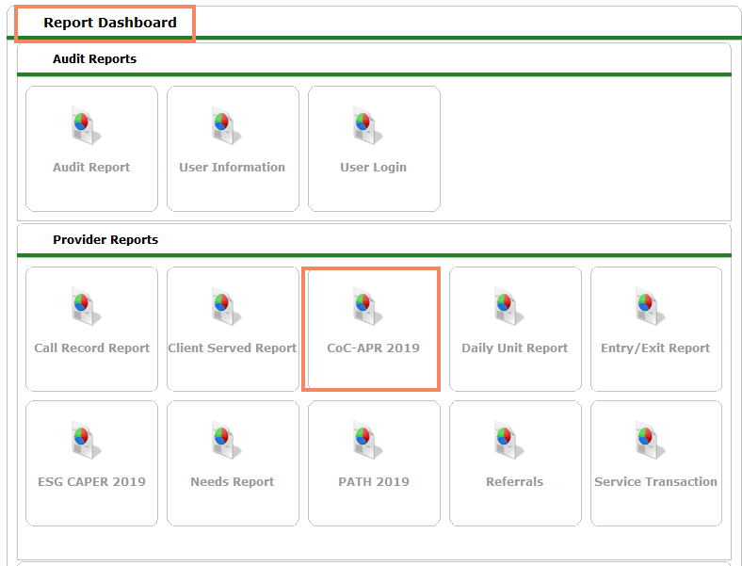
- Then complete the prompts for the date of the report you are having issues with, but with your agency provider.
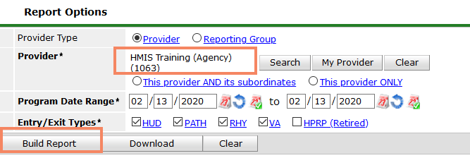
- If you see any clients in the report you know you will need to update their entry/exits with the correct provider.
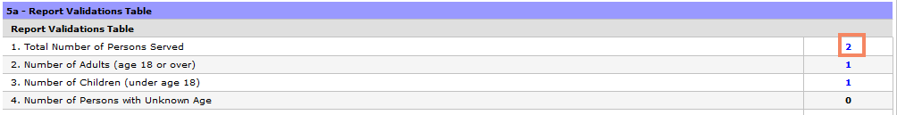
- You can click on the blue number of total number of persons served to get a list of the clients entered into the Agency level provider.
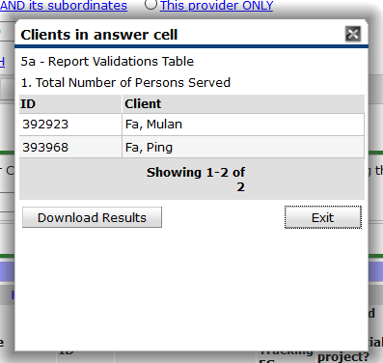
- Go to the client file and find the incorrect entry. Click the edit pencil on the entry.
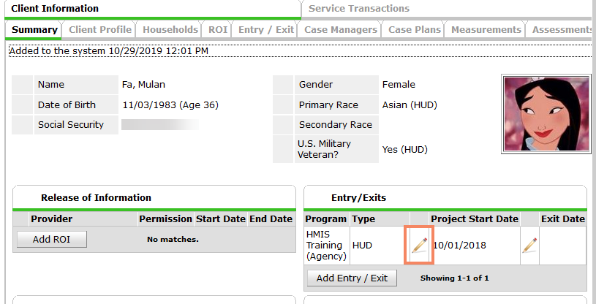
- This pop up will appear. Click Save & Continue
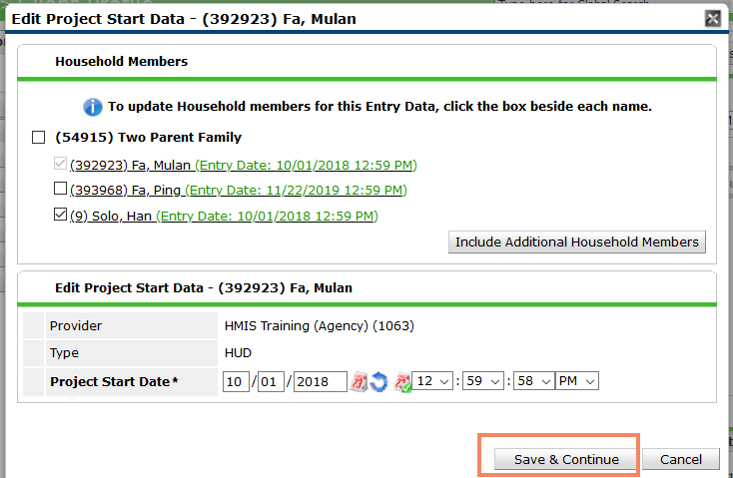
- Then at the top of the next pop-up you will click search next to the Provider.
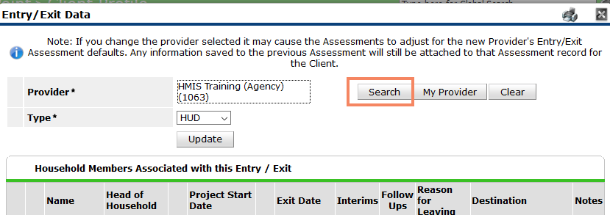
- Search for the provider you want the entry to be for. And add the correct provider with the green plus sign.
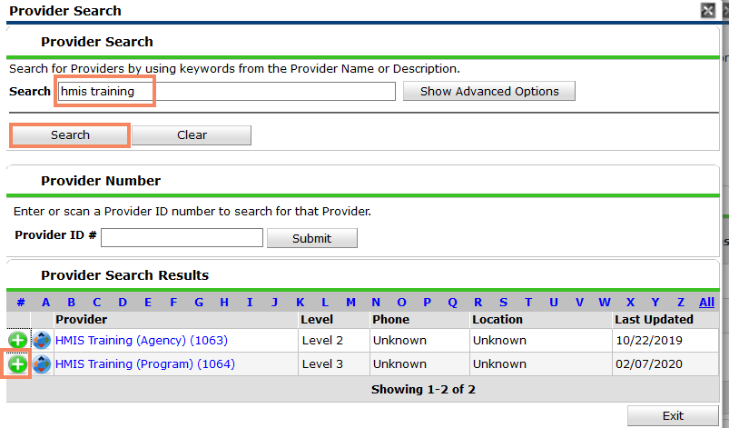
- In order for the change to take effect, you need to click Update. This will fix the entry for the entire household.
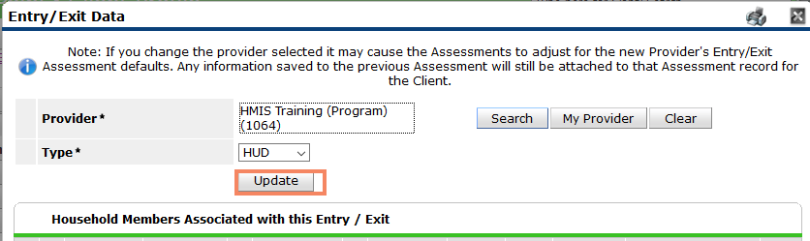
- You can re-run the CoC APR to confirm the fix is complete.

Duplicate entries for client/Household
If you are seeing that your HMIS count numbers are higher than your reported numbers, check to make sure that there are not duplicate entries created for the clients. The report sent to you will let you know if there are duplicate entries. They will appear highlighted in red, and the client id will be the same.
- Go to the client file of the client in question. You will see on the summary page that there are multiple entries open for your program.
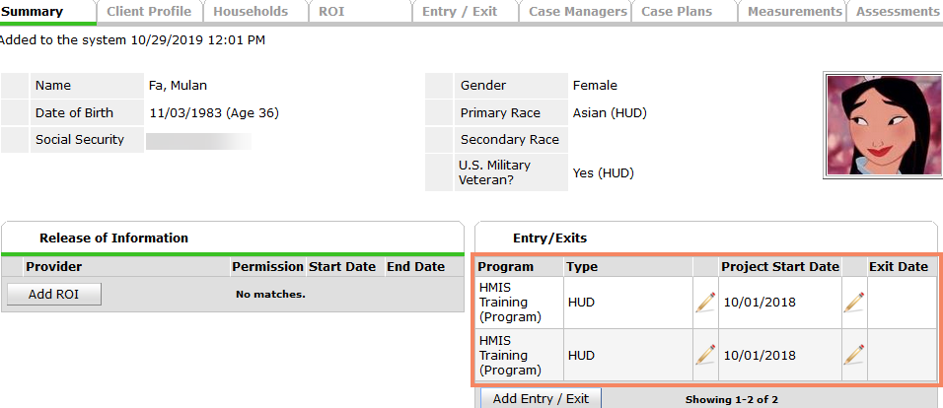
- Go to the entry exit tab. You will need to decide which entry needs to be deleted. Look at the number of clients in the client count section to see if one has a correct household composition and one does not. Also look at the interims section to see if one has interims – you will want to keep the entry/exit with the interims attached.
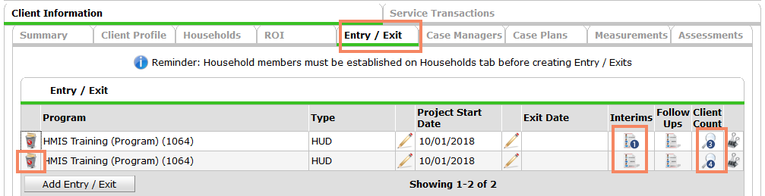

- If you click on the magnifying glass of the entry you are going to delete you will see all the clients associated with the entry. You will need to go to each of these client files to delete the entry/exit as well as the client file you are currently in.
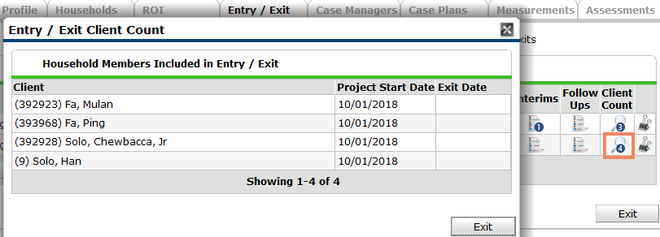
- Click on the trash can/recycling bin of the entry/exit you want to delete. A popup will appear. Select Yes. The entry/exit will be deleted for this client.
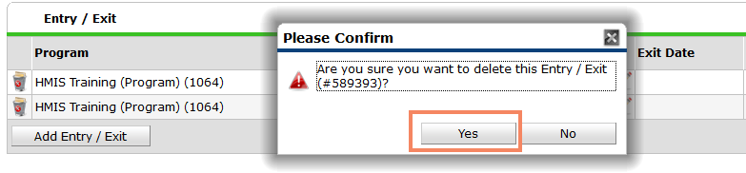
- You should then, remembering the clients associated with the deleted entry/exit, go to the “Switch to Another Household Member” dropdown and navigate to the next client file that needs the entry/exit deleted. This drop-down will take you directly to the same tab you are on in the current client’s file (the entry/exit tab here) but for the newly selected client. Repeat the steps above to delete the entry for all clients.
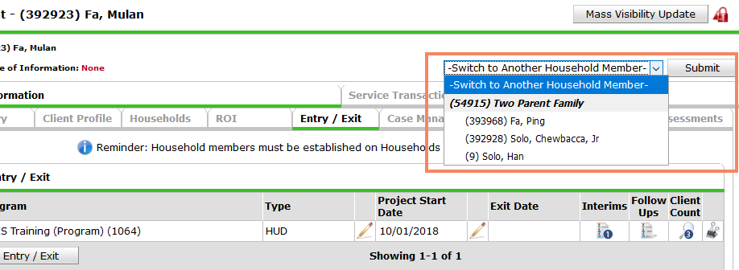

Unexited members of a household
Another common error when there are too many households entered into your program is that a household member was missed when exiting a household from your program. The client that is still entered will appear in the report but the other household members will not.
- To fix, go to the client file of the client in the report. You can see here that this client does have an open entry. Navigate to the entry/exit tab.
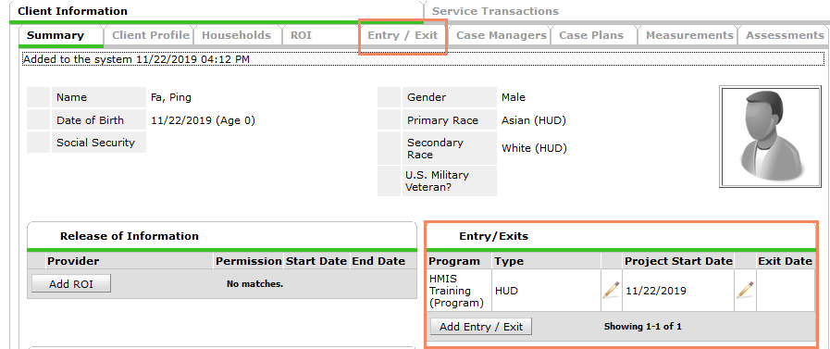
- Click on the client count magnifying glass to see that all other clients are exited and this is a child and thus should not be alone in the entry.
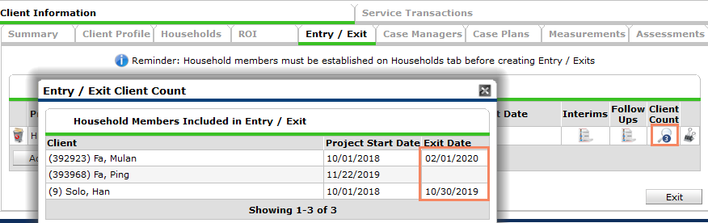

- Navigate to the head of household’s client file in order to exit the child with the head of household.
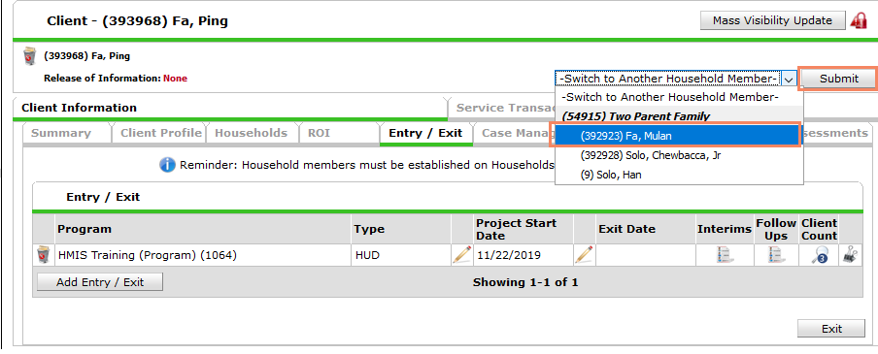
- Click the edit pencil of the head of household’s exit. Select the child that has not been exited yet and click Save & Continue.
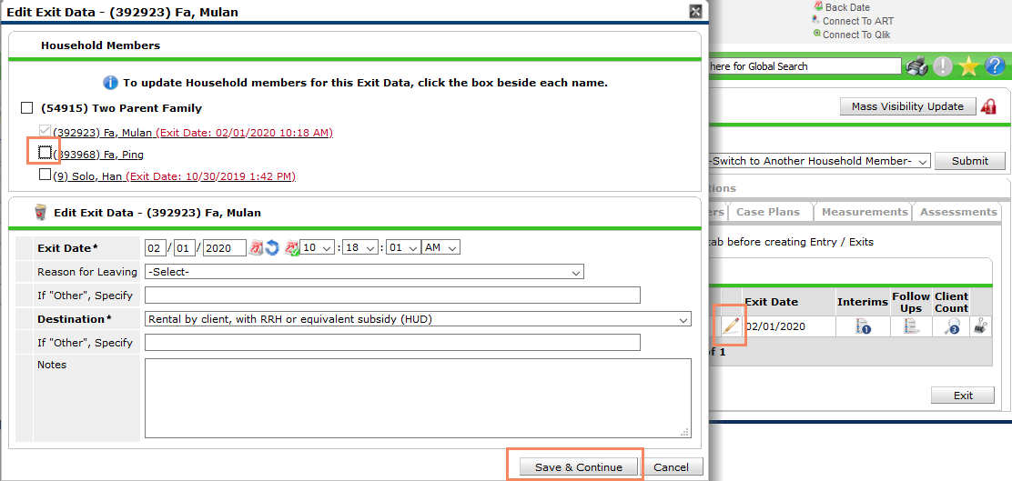
- You can now see that the child has the same exit date and destination as the head of household.
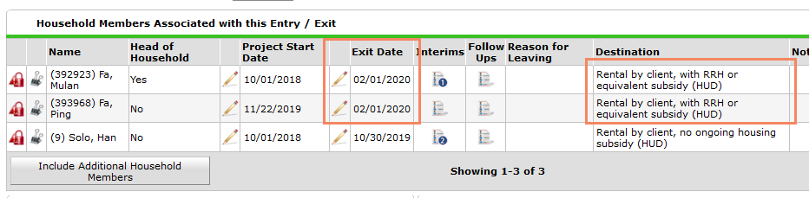

Projects Closing
If a program closes, for whatever reason, it needs to be communicated to the Weekly Occupancy Report so it can be properly removed from the Weekly Occupancy Report. All clients will also need to be exited from the program in HMIS.
  - Run the CoC APR (canned report) for providers that use Entry/Exits to show all clients with open entries since the date the program stopped serving clients/the grant ended/the agency changed
  - Run the Clients Served Report for providers that use ShelterPoint or SkanPoint to show all clients with open shelter stays or services since the date the program stopped serving clients/the grant ended/the agency changed
  - Exit all clients in these reports with accurate exit information.
  - Email the Weekly Occupancy Report at wor@community-partnership.org to inform us of when the project closed/left hmis.
If a program is doing a slow closing (removing units/open slots as clients move out) inform the Weekly Occupancy Report by emailing wor@community-partnership.org. We will keep the contracted number the same, but move the units to offline with a reason of program closing.

New Projects
If you receive new funding or have a new program that needs to/you want to enter into HMIS, they will also be included in the Weekly Occupancy Report if they have units. In order to get a new provider for HMIS for this program, complete the following survey (also located on the TCP website) New HMIS Provider Form. Allow for up to 2 weeks for the completion of the provider.
You will then need to email the Weekly Occupancy Report with the new program HMIS ID, the number of Contracted units you have, and the population you serve and when the program will begin operating.
Finally, complete the WOR Contact Information Form so we can set up who should receive the emails.

Changing who gets the emails
Who needs to make the weekly updates and receive emails about discrepancies can change over time. If a change needs to happen, complete the WOR Contact Information Form found at http://community-partnership.org/providers/hmis We require two points of contact, for coverage during time off etc.
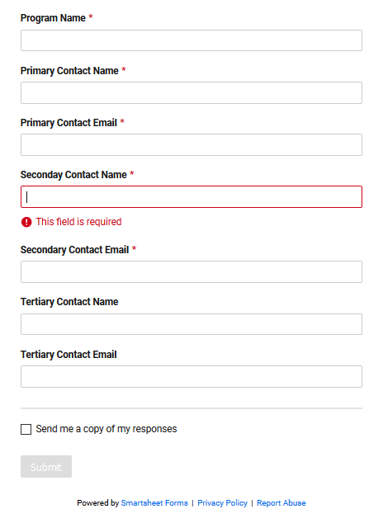

Who should be completing the Weekly Occupancy Report For our agency?
It is suggested that program managers, or those with knowledge of the number of offline and held units, as well as the reasons for the units being offline or held, should be the primary point of contact for the Weekly Occupancy Report.

We also might suggest someone familiar with HMIS and the data quality process as your secondary point of contact.

Other questions
If you have additional questions please contact the Weekly Occupancy Team at wor@community-partnership.org

New To the Weekly Occupancy Report?
Here are some pieces of information that should help orient you to the Report:

What it is
The Weekly Occupancy report has been around in one form or another for many years. It began as a way to see the system use of Transitional Housing programs and has over time grown to encompass more and more programs and program types. It is meant to be used as a tool to see a snapshot of our system’s occupancy and vacancy rates and to facilitate the coordinated entry process of matching clients to open beds in programs.

Limitations of this report
This report does have some limitations that should be noted before making decisions or publicizing anything in this report. This list may not be comprehensive.
- This report does not include all programs in DC’s CoC and cannot be used to discuss the COMPLETE system of DC’s CoC.
  - This report only includes programs that participate in HMIS. This means there are NO DV programs included in this report, nor are privately funded programs required to be in this report.
  - This report does not currently include most Low Barrier Shelters.
  - This report does not currently include Hypothermia Shelters
  - This report does not include Family Shelter Overflow Hotels/Motels.
- Some Agencies do not submit their held and offline units, so we cannot guarantee the numbers are 100% accurate.
- This is information that is true as of each Thursday. The further from Thursday, the less likely this information is still true.

Why we do it
- This report is used by our Coordinated Entry committees and teams to best navigate the process of placements of clients.
- It is also used by grant staff at TCP and DHS to monitor program's occupancy levels.
- This report gives individual program information as well as aggregate information about our homeless response system.
- This information is also used to Analyze trends in our system around vacancies and occupancy rates.

How you participate
Each week on Thursday you will complete this form for each of your programs.
The following Monday you will receive information on whether your HMIS information matches what you have submitted for that Thursday. You will make corrections to your HMIS information.
Rinse. Repeat.

Who should be completing this
It is suggested that program managers, or those with knowledge of the number of offline and held units, as well as the reasons for the units being offline or held, should be the primary point of contact for the Weekly Occupancy Report.
We also might suggest someone familiar with HMIS and the data quality process as your secondary point of contact.

