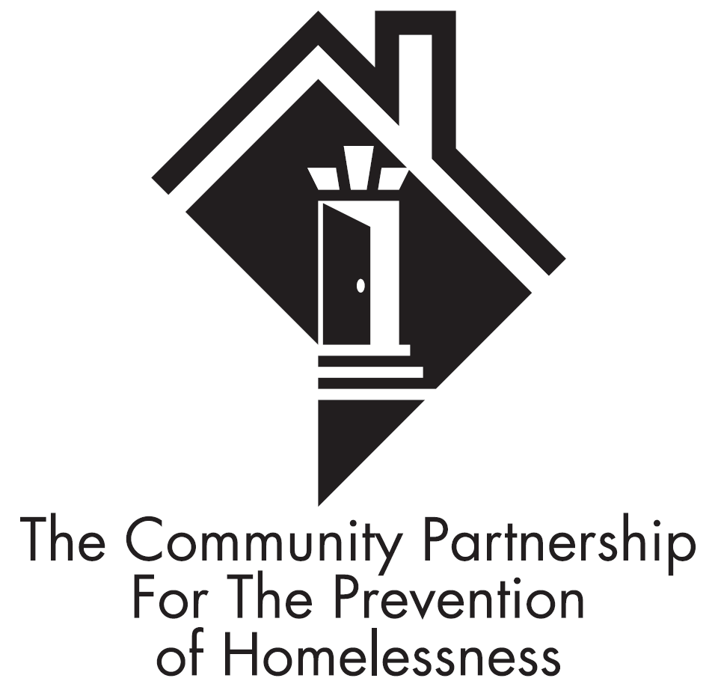

THE COMMUNITY PARTNERSHIP
FOR THE PREVENTION OF HOMELESSNESS

Scattered Site Virtual Audit Checklist

Contractor Name:
Contract Period:
Contract Number:
Program Name(s):

Program Type:
Capacity:
Target Population:

Contact Person (s)/Title:
Email Address:
Program Address:
Phone:

Overview: Each program funded by The Community Partnership for the Prevention of Homelessness (TCP) is subject to an audit at minimum once per year in an effort to ensure compliance with the requirements outlined in your TCP issued contract. As a part of the completion of a Desk Audit, this form is required to be completed in its entirety and submitted via email to the TCP representative identified in the email in which this form was issued. Please answer the below questions regarding the office space that is used to meet with program participants. *Please note that some of the questions below requires you to submit a picture to support your answer. The questions that require the submission of a picture includes a red asterisk at the beginning of the question. Pictures can be provided via email along with the submission of this form.

- Does the office space that is used to meet with program participants have properly functioning fire extinguishers? ☐Yes ☐ No

- Please include the number of fire extinguishers included in the facility: (If the facility has more than one floor, please indicate how many fire extinguishers are included on each floor).

- Please include the dates in which each fire extinguisher was last serviced/inspected by DC F&EMS:

- *(Photo Required) Does the office space which is used to meet with program participants have emergency evacuation routes posted and visible?
☐Yes ☐ No
- *(Photo Required) Does the office space have exit signs posted at all exits?
☐Yes ☐ No
- *(Photo Required) Does the office space have the “Interpreter Services Available”, Desktop Display posted and visible at the front desk as well as the area used for client intakes?
☐Yes ☐ No
- *(Photo Required) Does the office space have the “Confidentiality Poster”, posted and visible?
☐Yes ☐ No
- *(Photo Required) Does the office space have the “ADA” poster posted and visible in both English and Spanish?
☐Yes ☐ No
- *(Photo Required) Does the office space have the “How to File a Complaint” poster posted and visible?
☐Yes ☐ No
- Is the office space used to meet with program participants handicap accessible?
☐Yes ☐ No
- *(Photo Required) Does the office space have the updated Living Wage Acknowledgement poster displayed?
☐Yes ☐ No
- *(Photo Required) Are client files stored in a doubled locked setting?
If unable to provide a photo to indicate that client files are stored in a doubled locked setting, please explain how the above requirement is met at your office:

- Does the office space include a means for clients to provide feedback about program services? (i.e. suggestion boxes, directions on how to provide program feedback...etc.) Please explain.

- *(Photo Required) Are COVID-19 guidelines regarding social distancing as well as mask mandates displayed in the office space used to meet with program participants? Please provide pictures to support your explanation. (i.e. pictures of 6ft apart indicators on the floor, posted signs regarding mask requirements, etc.).

Name and title of Employee completing form
Signature Date

