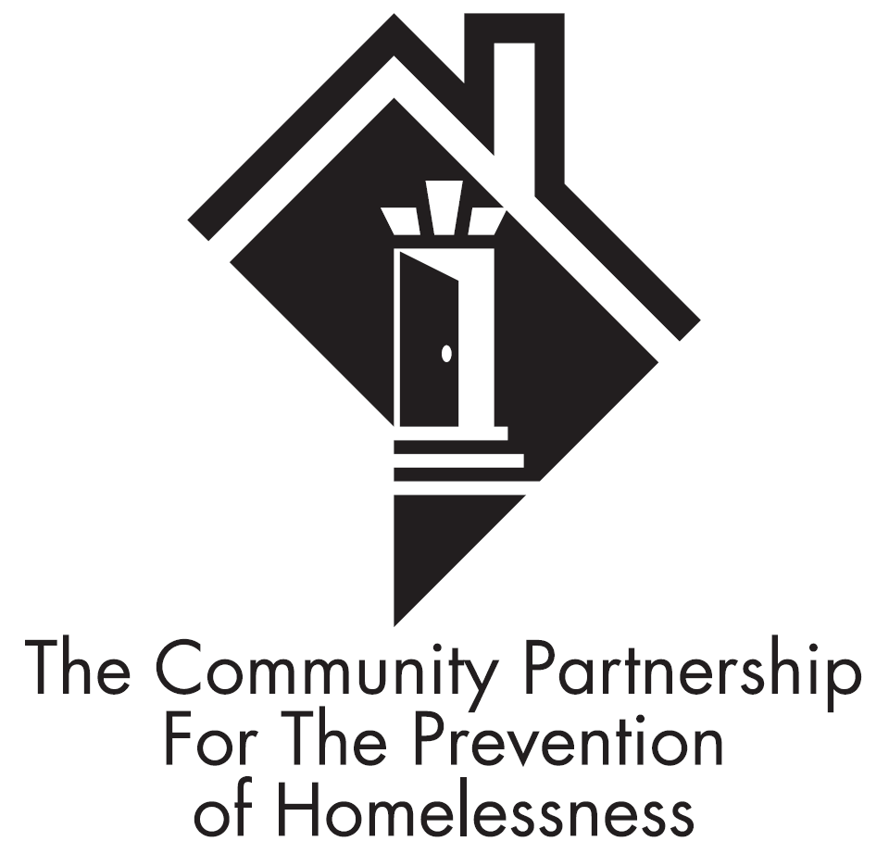

THE COMMUNITY PARTNERSHIP
FOR THE PREVENTION OF HOMELESSNESS

Virtual Audit Checklist

Contractor Name:
Contract Period:
Contract Number:
Program Name(s):

Program Type:
Capacity:
Target Population:

Contact Person (s)/Title:
Email Address:
Program Address:
Phone:

Overview: Each program funded by The Community Partnership for the Prevention of Homelessness (TCP) is subject to an audit at minimum once per year in effort to ensure compliance with the requirements outlined in your TCP issued contract. As a part of your audit, this form is required to be completed in its entirety and submitted via email to the TCP representative identified in the email in which this form was issued. Please answer the below questions regarding your program. *Please note that some of the questions below requires you to submit a picture to support your answer. The questions that require the submission of a picture includes a red asterisk at the beginning of the question. Pictures can be provided via email along with the submission of this form.

- Does your program site have properly functioning fire extinguishers? ☐Yes ☐ No

- Number of fire extinguishers included in the facility: (If your facility has more than one floor, please indicate how many fire extinguishers are included on each floor).

- Please include the dates in which each fire extinguisher was last serviced/inspected by DC F&EMS:

- Please include the most recent date in which your program site had a fire safety inspection completed by DC F&EMS?

- *(Photo Required) Does your program site have emergency evacuation routes posted and visible?
☐Yes ☐ No
- *(Photo Required) Does your program site have exit signs posted at all exits?
☐Yes ☐ No
- *(Photo Required) Does your program site have the “Interpreter Services Available”, Desktop Displays posted and visible in intake and/or communal areas of the facility?
☐Yes ☐ No
- *(Photo Required) Does your program site have the “Interpreter Services Available”, Desktop Displays posted and visible at the front desk of the facility?
☐Yes ☐ No
- *(Photo Required) Does your program site have the “Confidentiality Poster”, posted and visible in the intake and/or communal areas of the facility?
☐Yes ☐ No
- *(Photo Required) Does your program site have the “ADA Poster”, posted and visible in the intake and/or communal areas of the facility in both English and Spanish?
☐Yes ☐ No
- *(Photo Required) Does your program site have the “How to File a Complaint” poster displayed in the intake and and/or communal areas of the facility?
☐Yes ☐ No
- *(Photo Required) Is the site in which services are rendered handicap accessible?
☐Yes ☐ No
- *(Photo Required) Does your program site have the Living Wage Acknowledgement poster displayed?
☐Yes ☐ No
- *(Photo Required) Does your program site have updated Program Rules displayed?
☐Yes ☐ No
- *(Photo Required) Are client files stored in a doubled locked setting?
If unable to provide a photo to indicate that client files are stored in a doubled locked setting, please explain in detail how your program site meets the above requirement:

- How does your program offer clients a means to provide feedback about program services? (i.e. suggestion boxes, weekly house meetings, etc.).

- *(Photo Required) Please indicate below how your program is adhering to COVID-19 guidelines regarding social distancing as well mask mandates. Please provide pictures to support your explanation. (i.e. pictures of 6ft apart indicators on the floor, posted signs regarding mask requirements, etc.).

Name and title of Employee completing form
Signature Date

