Updated 6/30/2026
Introduction to Absorb, TCP’s LMS

What is a Learning management System (LMS)?
A digital platform for delivering, tracking and managing online trainings. This includes management of training registration, completion, and certificates.

How will user access the LMS?
User will navigate to https://community-partnership.myabsorb.com/#/login. All first-time users will need to Sign Up using the sign-up button
DO NOT USE THIS KEY IF YOU HAVE ALREADY CREATED AN ACCOUNT FOR HMIS TRAININGS. *If you have an HMIS account already, simply log-in to your existing account.
The Key Name is tcptraining
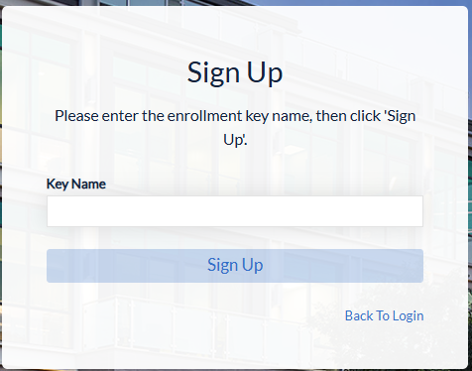
For additional details about sign-up, review the “How to Sign Up for a New Account” document.

What trainings are available in the LMS
Currently, there are only a few on-demand courses in the LMS. Gradually, we’ll transition most of the live and on-demand trainings to this system.

Who should use the LMS?
As of June 2026, you only need to use the LMS if you need to complete a course which is only offered in the LMS. This will be noted in the training calendar. Eventually, all staff who need to take TCP trainings will use the LMS.

Do I have to register for a training on the LMS?
Currently, all trainings in the LMS are on-demand and require enrollment, but not advanced registration. When live trainings are added, you will need to register for those.

How long does it take to complete a training?
Currently, all the trainings in the LMS are on-demand and self-paced. Users can complete trainings in the time frame that works best for them. The trainings will vary in length.

